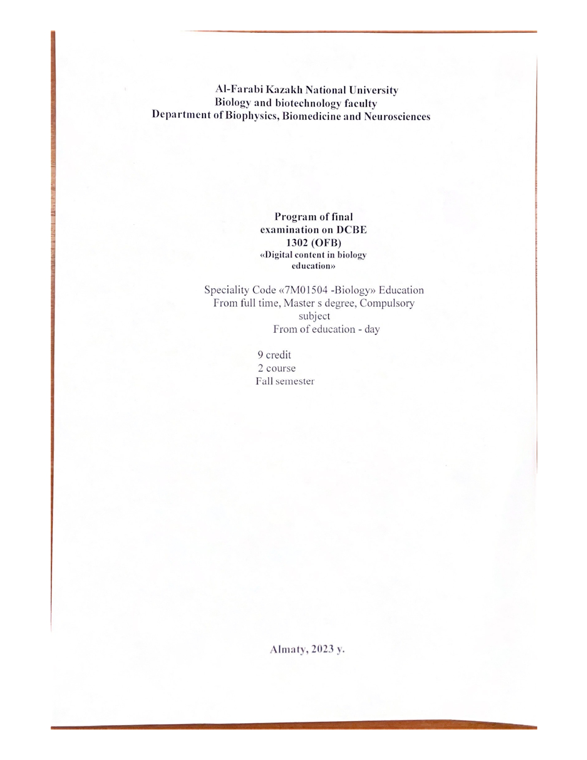
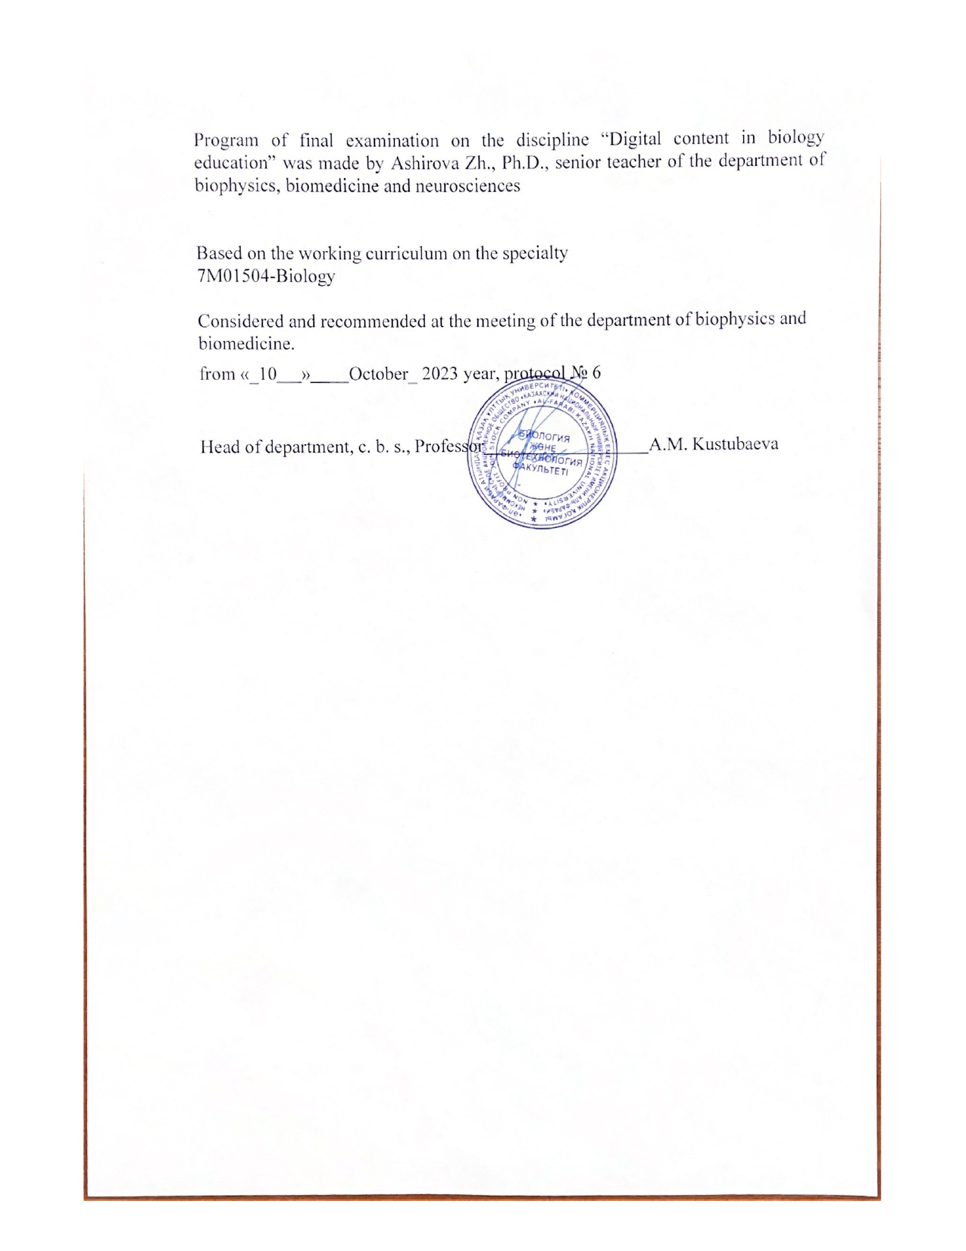
The KAZAKH NATIONAL UNIVERSITY of al-Farabi
Faculty biology and biotechnology Methodological recommendations for Final Exam
« DCBE 1302 » - « Digital content in biology education »
Exam Type: Offline (Traditional format), Writing
Exam format-offline
Conducted in writing: IS Univer
Recording control - offline proctoring.
Duration - 120 minutes for 3 questions, 1
Conducting rules:
General Exam Rules
The exam is held according to the schedule recommended by the faculty during the session. In order to verify the identity of the master student taking the exam, the teacher on duty checks the relevant documents (identity card or passport). If another person took the exam, the on-duty teacher draws up an act of violation of the rules. In the case of taking an exam at the university, 15 minutes before the start of the exam, the teacher on duty signs the arrival list with the seat numbers of the students and seats them. In the autonomous mode, it is necessary to start the exam in a timely manner and after the full recording of the exam answers, hand over the exam tickets to the duty officer and leave the exam with the teacher's permission.
During the exam, the teacher on duty monitors the order of the students in accordance with the approved instructions.
In the case of taking a written exam at the university, in a special examination room (with camera surveillance), the examiner sits down in the designated place, a sealed envelope is opened in front of the examiners, the teacher on duty distributes tickets to the examiners. Students are issued a ticket with 3 questions. Students must master video, presentation, lecture materials on predetermined topics. In the answer, it is necessary to reveal the theoretical content and practical basis of the topic.
The deciphered exam answers are received by the checking teacher and evaluate the response work in a special room with a camera according to the grading scale. Graded exam answers will be returned to the registrar's office. The grades set in the answers to the exam by the registrar's office are assigned by the students to the checking teacher by filling in the dossier (sheet) with points-points indicating the surname and initials. The checking teacher puts down points on the electronic document-information in the "Univer" system, prints out the document-information on paper, signs and transfers to the registrar's office.
The time for scoring (points) in the consolidated summary sheet (Sheet) of the written exam is 48 hours.
During the exam, it is forbidden to use a crib, mobile phone, dictionary, calculator, talk to each other, etc. In case of non-compliance with this provision, the student is removed from the exam, an appropriate act is drawn up and an “F” (unsatisfactory) mark is given for the subject.
A student who repeatedly violates the rules of the exam may be expelled from the university by the decision of the ethics faculty council in accordance with the rules of the internal procedure of KazNU named after Al-Farabi.

Topics of the final exam in the discipline «Digital content in biology education»

1. The purpose, objectives and relationship of the subject of digital content in biological education with other sciences
2. To determine how and why digital technologies in biological education can be used in their practice, with reference to relevant concepts,
Principles and theories
3 Potential of digital technologies in education, methods of statistical control of the quality of Education
4. Development of principles and concepts related to the use of digital technologies in biological education (using the example of Microsoft word)
5 Features of the use of digital technologies in the school, the development of skills of the XXI century among students
6. Understand the problems associated with the use of digital technologies in biological education and apply them in their own practice (using the example of Microsoft excel)
7. «Development of scientific publications on Master's topics using Microsoft programs»
Project work – use any example of your report as a Master peace
Demonstrate at any available program.
8. Features of the use of digital technologies in biology lessons
9. Planning, preparing and conducting classes using one or more
digital technologies
10. Colloquium – logical task
Development of glossary of the course material.

11 The importance of using digital technologies in active and inclusive learning
12 Demonstrate how you can develop an active learning and inclusive learning environment using digital technologies, as well as engage and motivate students to learn.
13. Stages and concept of composition of the electronic textbooks
14 Research of electronic textbook compiling programs
15 Different tools for writing an e-book
16 Drawing up the content of an electronic textbook
17 Ways to add and edit video and audio recordings to an e-book or texts
18. Adding and editing video and audio recordings to an e-book or texts
19 Formation of information and communication competence in biological education
20 Selection of appropriate digital technologies for the design of learning activities specific to the development of different skills
21 Psychology of personality and interpersonal relationships in biological education using digital technologies
22 Identify strengths and directions in designing educational
23 SMART Learning technology in biological education
24 Collaborative environment choosing the most effective form of lesson organization
25 Review of the methodology and system of distance learning, Mass Open Online Courses
26 Analysis of modern technologies of online events
27 Use of multimedia technologies in biological education
28. Intensification of the educational process using multimedia technologies in biological education
29 Assessment of students' knowledge using digital technologies in biological education (Quiz programs)
30 Working with the Free Quiz Maker program
31 Colloquium Make a structural and logical diagram of the read material – logical task
32 Features of working with Converter programs in biological education
33 Working with Freemake Video Converter

Evaluation criteria
Below are the minimum scores in percentages:
95% - 100%: A 90% - 94%: A-
85% - 89%: B+ 80% - 84%: B 75% - 79%: B-
70% - 74%: C+ 65% - 69%: C 60% - 64%: C-
55% - 59%: D+ 50% - 54%: D- 0% -49%: F

EVALUATION CRITERIA

"EXCELLENT" - the student has knowledge of the subject in the full scope of the curriculum, comprehends the discipline deeply enough; independently, in a logical sequence and exhaustively answers all the questions of the ticket, while emphasizing the most essential, is able to analyze, compare, classify, generalize, concretize and systematize the studied material, highlight the main thing in it: establish cause-and-effect relationships; clearly forms answers, freely reads the results of analyzes and other studies and solves situational problems of increased complexity; familiar with the main literature

"GOOD" - the student has knowledge of the discipline in almost the entire scope of the program (there are gaps in knowledge only in some, especially complex sections); does not always highlight the most significant, at the same time does not allow serious errors in the answers; able to solve light and moderate situational problems; is able to interpret laboratory and instrumental studies in excess of the mandatory minimum.

"SATISFACTORY" - the student owns the main body of knowledge in the discipline; shows difficulty in independent answers, operates with inaccurate formulations; in the process of answering, mistakes are made on the merits of the questions. The student is able to solve only the easiest problems, owns only the mandatory minimum of research methods.

"UNSATISFACTORY" - the student has not mastered the required minimum knowledge of the subject.

References
- Teaching and Digital Technologies: Big Issues and Critical Questions Paperback. January 8, 2016 by Michael Henderson (Editor), Geoff Romeo (Editor)
- Biancarosa, G., & Griffiths, G. C. (2012). Technology tools to support reading in the digital age. The Future of Children, 22(2), 139-160. http://www.jstor.org/stable/23317415?seq=1&cid=pdf- reference#page_scan_tab_contents
- Forsyth, E. (2016). Using videoconferencing for professional development and meetings. Computers In Libraries, 36(7), 11-14.
- Remis, K. K. (2015). LMS enhances K12 instruction: Systems increase engagement, provide quick access to digital resources and help teachers with administrative tasks. District Administration, Digital Edition, May 27, 2015. http://www.districtadministration.com/article/lms-enhances-instruction
- Dominic, M. (2016). Handbook of Research on Mobile Learning in Contemporary Classrooms. Hershey, PA: IGI Global.
- Korakakis, G. G., Pavlatou, E. A., Palyvos, J. A. and Spyrellis, N. N. (2009) “3D visualization types i n multimedia applications for science learning: A case study for 8th grade students in Greece”, Computer s & Education, Vol 52, pp 390‐401.

